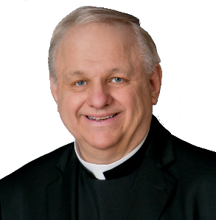
Message from our Pastor
Father Steve

Title: “GPS, Gas Pumps, and the Gospel”
Weekly Reflection – Father Steven Pautler
Luke 12:35–40 – 19th Sunday in Ordinary Time, August 10, 2025

A few years back, I had the great joy of attending the priestly ordination of Father Ben Wanner, who had spent a short time at St. Mary’s in Centralia during his deacon year. The ordination was in Bismarck, North Dakota, beautiful country, wide skies, and very, very far from Southern Illinois. It was a wonderful day, filled with sacred moments, joyful tears, and enough cassocks to start a small Vatican.
Afterward, I decided to take the scenic route home. And by scenic, I mean I let my GPS choose the way and off I galloped toward Mount Rushmore, planning to swing through the Badlands and see a bit of God’s dusty handiwork before returning home. Now, here’s where it gets biblical.
Somewhere deep in the Dakotas, somewhere between “nope” and “you’re on your own,” my GPS lost its signal. My phone was tethered to the dashboard like a digital compass, and suddenly... silence. No beeps. No arrows. Just an eerie quiet and a fuel gauge giving me the side-eye with a measly quarter tank of gas. I thought, “Well, isn’t this how every episode of Dateline starts?” Panic? Yes. Concern? Oh yes. Preparedness? Zero.
As I coasted through empty plains and dusty hills, I was reminded of today’s Gospel: “Be prepared, for at an hour you do not expect, the Son of Man will come.” And I thought, “Well Lord, if this is my hour, I sure hope You like the Badlands.”
But then, salvation, on the horizon, a shimmering beacon of hope: a mom-and-pop gas station with one gas pump and a screen door that creaked like it was auditioning for a horror film. I filled up, walked inside, and asked for a map, yes, an actual paper map. The lady behind the counter looked at me and said with a knowing smirk, “Ah… another one.” Apparently, I wasn’t the first lost soul whose GPS took them on the scenic road to sanctity.
She reached under the counter, pulled out a Dakota Territory map, and with a yellow highlighter, drew me a safe route back to civilization. She even gave me the map for free. That’s hospitality.
Friends, today’s Gospel isn’t just about the Second Coming. It’s about daily readiness. It’s about spiritual fuel. It’s about not relying solely on the world’s “GPS,” but occasionally grabbing the well-worn map—Scripture, prayer, the Sacraments—and letting God highlight the way. So, gird your loins. Keep your lamps lit. And for the love of St. Christopher, always keep more than a quarter tank of gas.

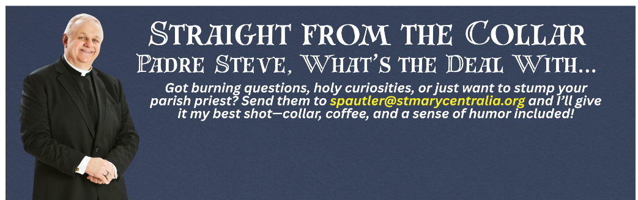

This week’s question: "If I receive Communion at a Catholic wedding Mass or funeral Mass on a Saturday, can I receive Communion again that evening at the Saturday Vigil Mass?"

Answer: Yes, you can! The Catholic Church allows you to receive Holy Communion twice in one day, as long as the second time is during a Mass that you attend. So, if you go to a Catholic wedding or funeral Mass on Saturday and receive Communion, and then attend the Saturday evening Vigil Mass (which fulfills your Sunday obligation), you’re absolutely allowed to receive Communion again at the Vigil. The key is that the second Communion must be within a full Mass, not just a Communion service. So go ahead—receive Jesus again with a grateful heart!

